

**Project 1: Simply Blogging**

Name: Abdulelah Hassan Abbas

Username: Abdu.e.h.c@gmail.com

Report

The Steps Below is how I made the website:

Step1: the requirement used for project

Visual studio code: editor

Bootstrap

Html/CSS

Git/GitHub

JavaScript

Step2: the directory of this project:

First: creating the Directory to start the project

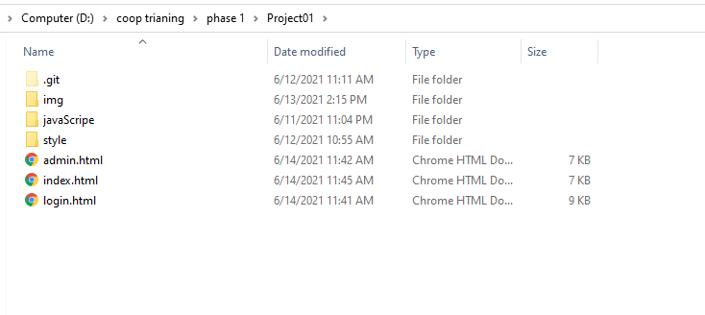

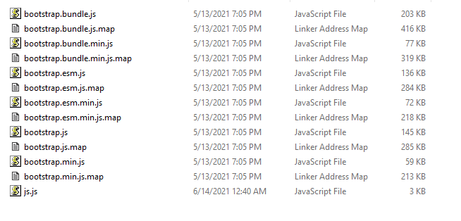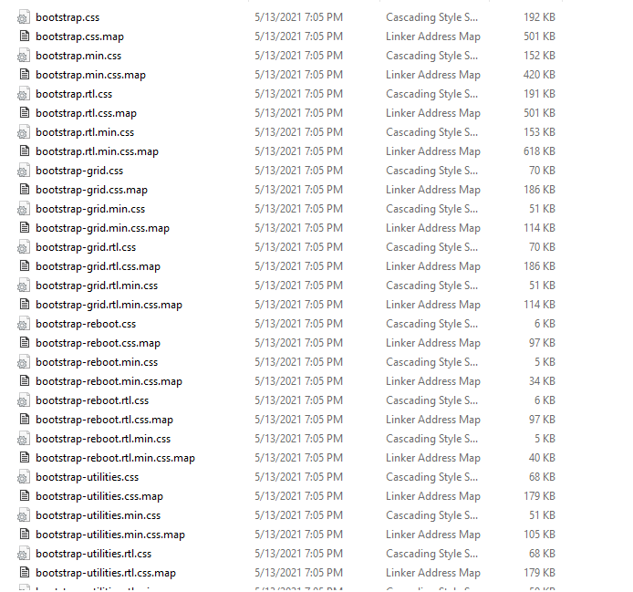

Step3: the index.html design

Note: For the navbar and footer I used the same one for all pages.

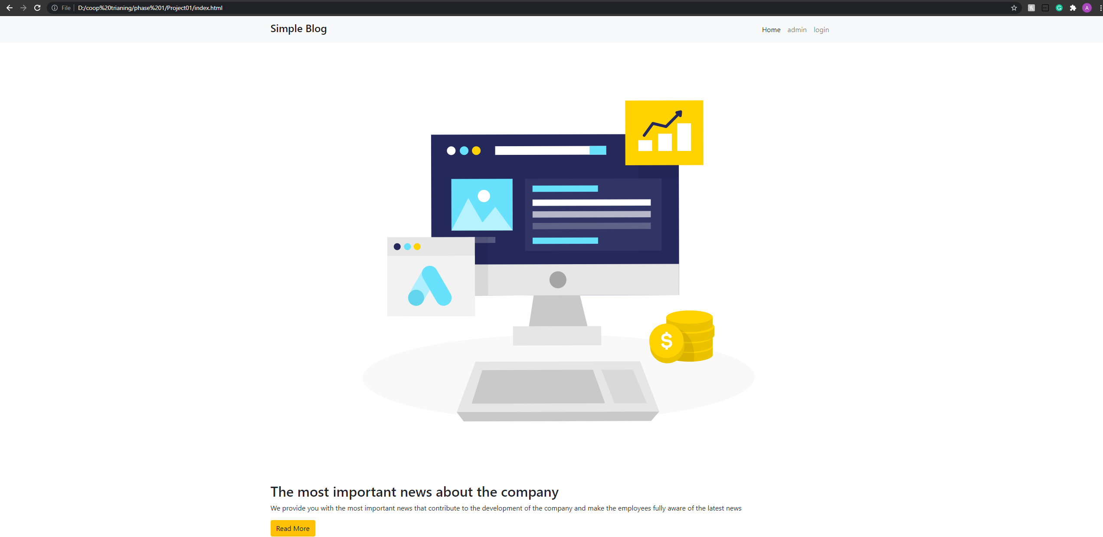

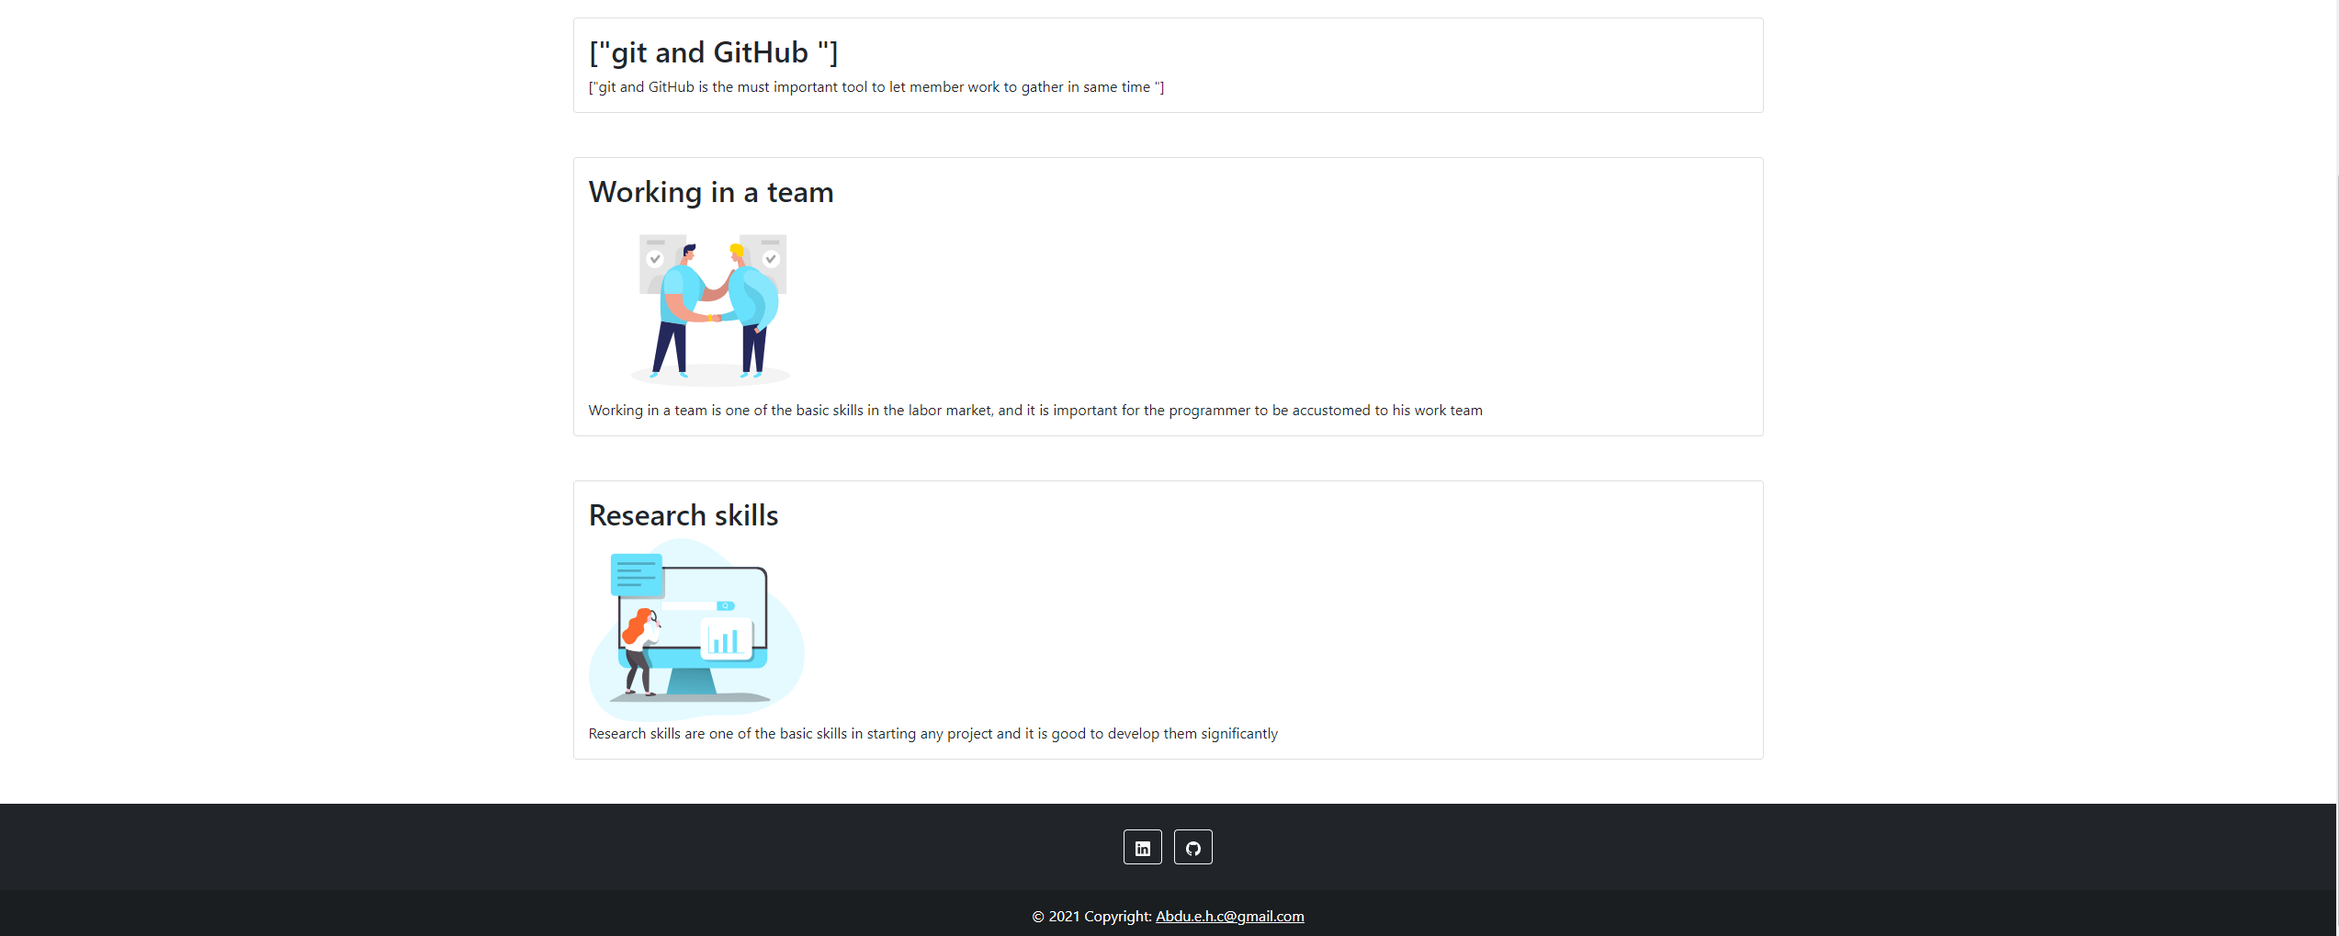

Step4: the login.html design:

Note: the username = admin, password = 1221

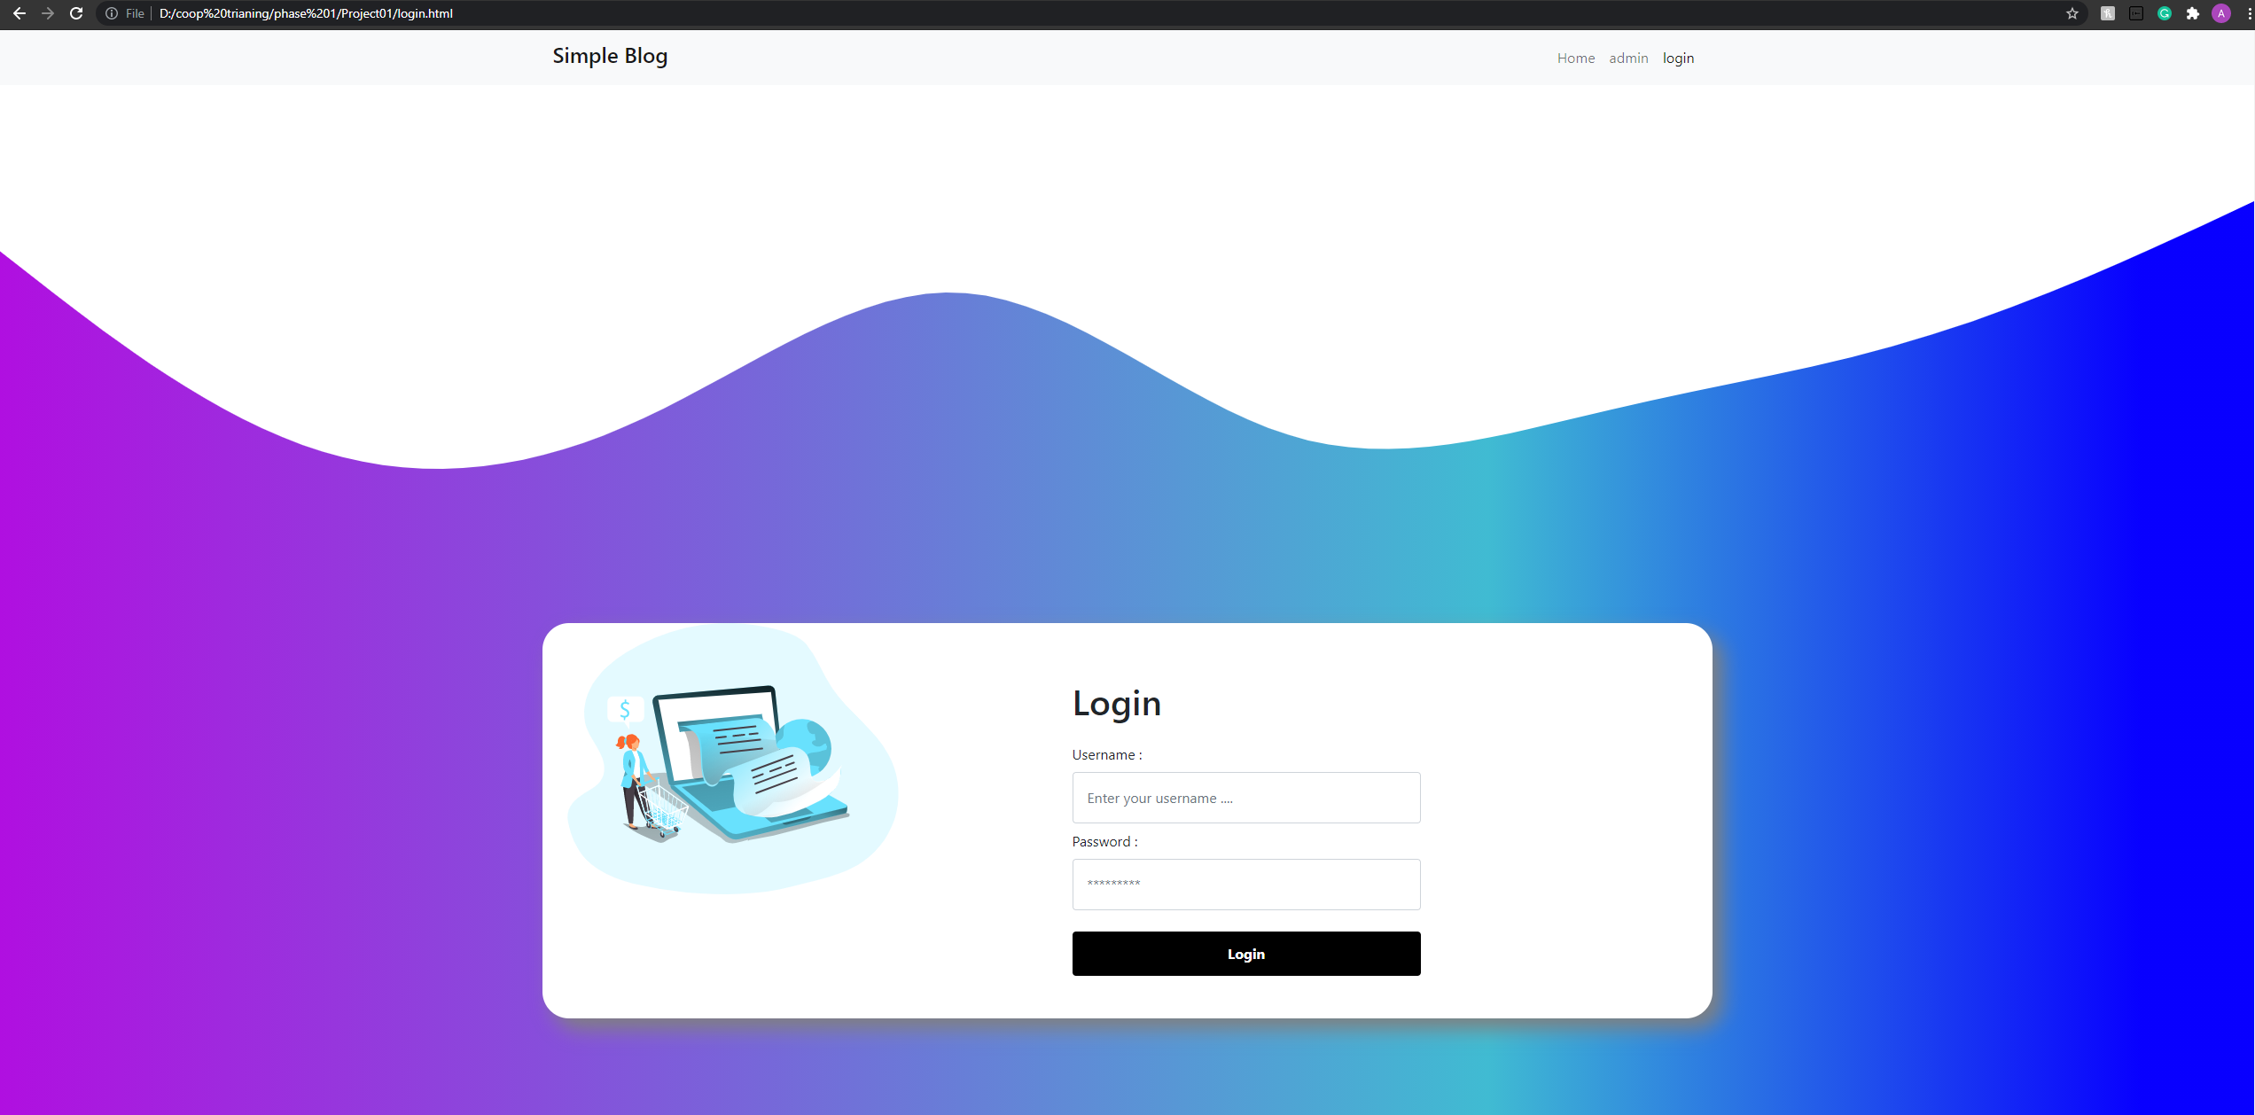

For the validation of the login, it is as follows:

1. 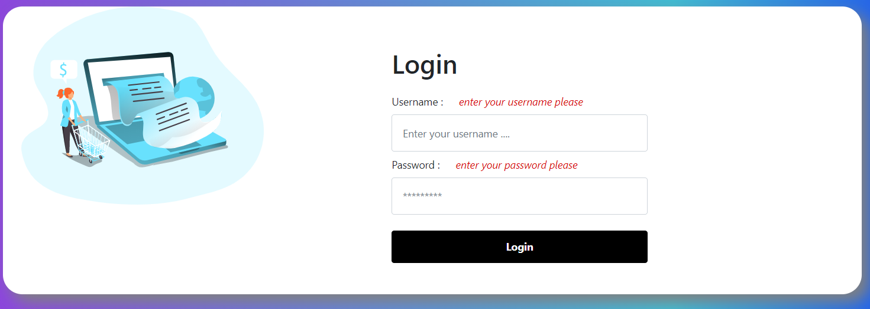If the input is null:
2. 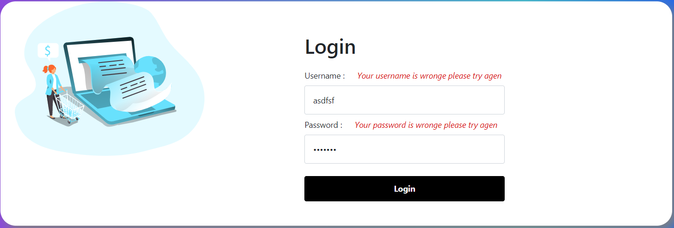If the user input the username only:
3. 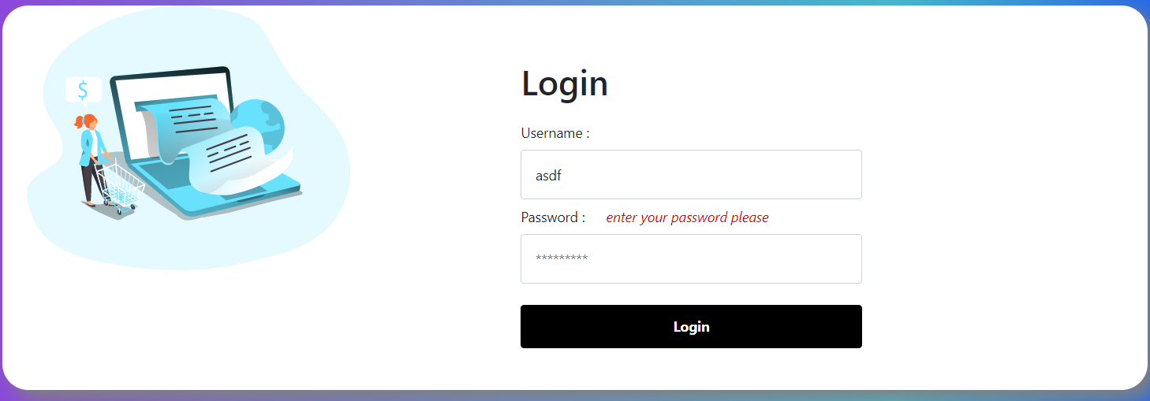If the user input wrong username and password:

Step5: the admin.html design

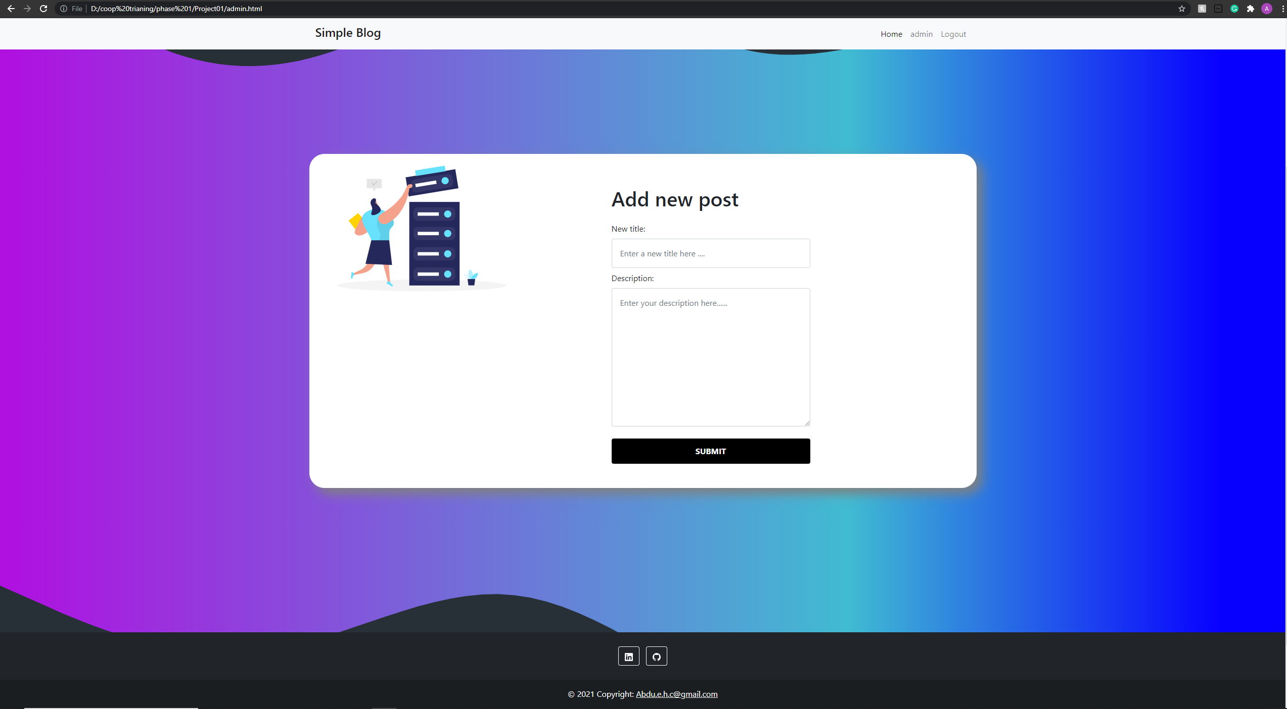

Step 6: after the admin add new post it will insert into local storage as following:

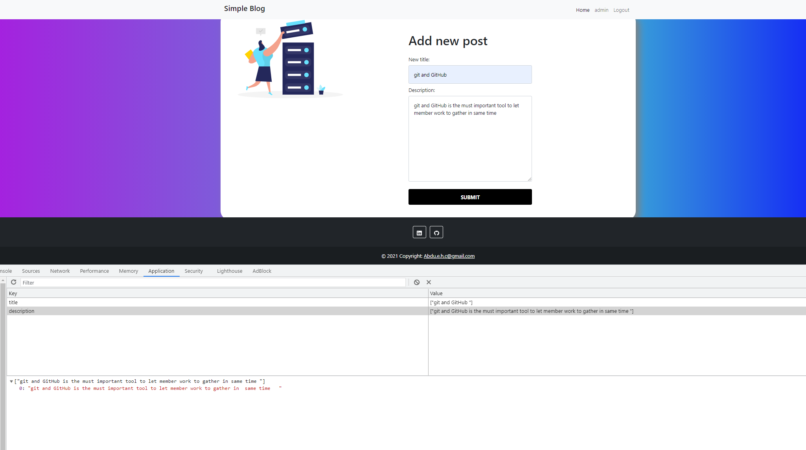

Step 7: after you add a new post go back to home and click the button

“Rede More” to show the new post:

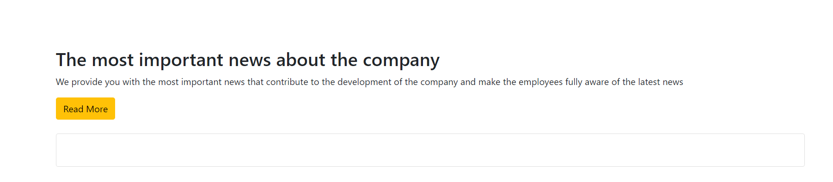

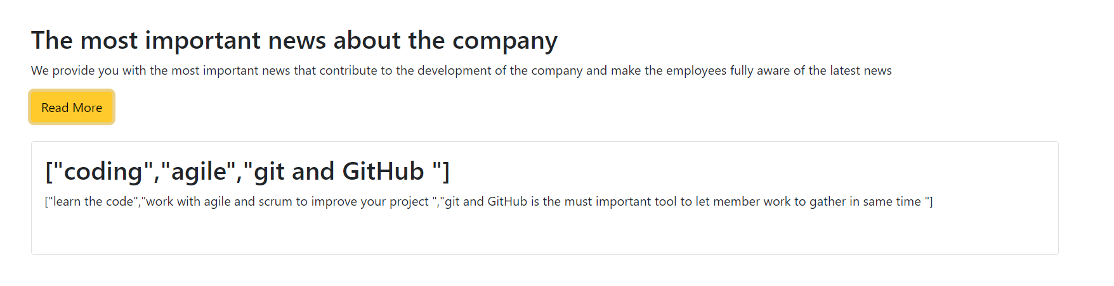

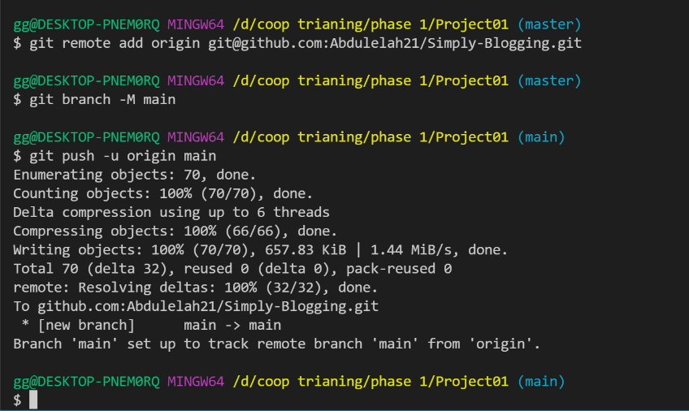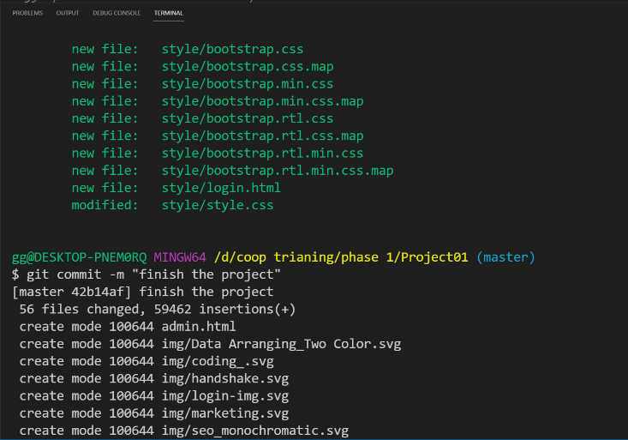Step 8: using git and githup to push all file in the Repository Simply Blogging: